WeatherPy.jpynb - Run results

After executing the WeatherPy.jpynb, verify the output_data folder

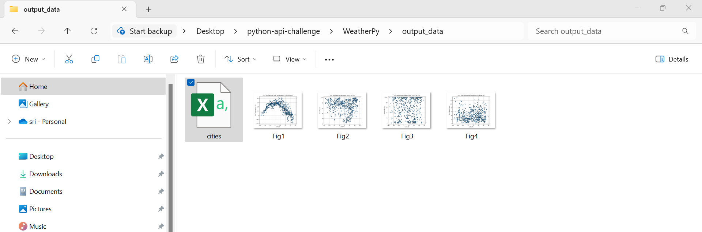

Vacation.jpynb- Run results

